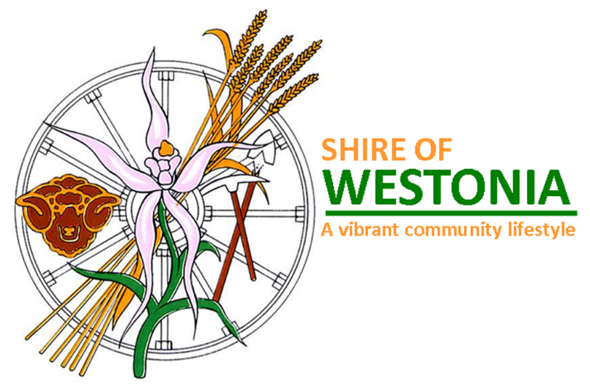

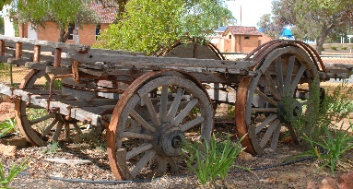
Disability Access and Inclusion Plan 2017-2021
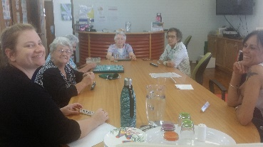
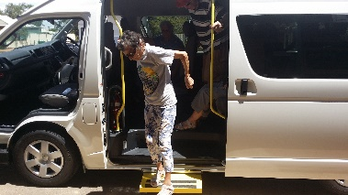
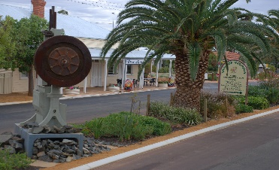
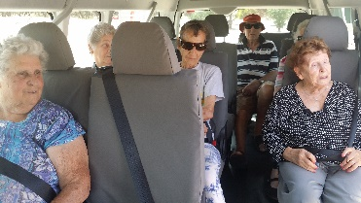

This plan is available via the Shire of Westonia website, or upon request in alternative formats such as large print, electronic format (disk or emailed), audio.

Table of Contents
1. BACKGROUND & HISTORY 3

1.1 Westonia in Brief “Where the Wheatbelt meets the Goldfields.” 3
1.2 Westonia Locality 5
1.3 Responsibility for Planning Process 5
1.4 Functions, Facilities and Services (Both in-house and contracted) 6
1.4.1 Services to property 6
1.4.2 Recreation Services to the community: 6
1.4.3 General Services to the community: 6
1.4.4 Local Government Regulatory Services to the community: 6
1.4.5 Local Government Administration Services to the community: 6
1.4.6 Processes of Local Government: 6
1.5 Access and Inclusion Policy Statement for People with Disabilities, Their Families and Carers 7
1.6 Community Consultation Process 7
1.7 People with Disability in the Shire of Westonia 8

2 ACCESS AND INCLUSION POLICY STATEMENT FOR PEOPLE WITH DISABILITY, THEIR FAMILIES AND CARERS 9

3 DEVELOPMENT OF THE DISABILITY ACCESS AND INCLUSION PLAN 10
3.1 Responsibility for the planning process 10
3.2 Review and Community Consultation Process 11
3.3 Findings of the Review 11
3.4 Responsibility for implementing the DAIP 12
3.5 Communicating the plan to staff and people with disabilities 12
3.6 Review and evaluation mechanisms 12
3.7 Review and monitoring 13

4 REPORTING ON THE DAIP 13

5 STRATEGIES TO IMPROVE ACCESS AND INCLUSION 13

6. IMPLEMENTATION PLAN 17

7 PROGRESS SINCE 1995 UNDER THE DISABILITY SERVICE PLAN AND THE DISABILITY ACCESS AND INCLUSION PLAN. 25

1. BACKGROUND & HISTORY

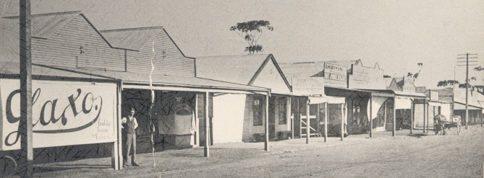

1.1 Westonia in Brief “Where the Wheatbelt meets the Goldfields.”
The Shire of Westonia is a small rural community located near the eastern border of the Central Wheatbelt Region. The Shire takes its name from the main townsite named Westonia, which was named after Alfred David Weston, a sandalwood cutter who also prospected and discovered gold near the Boodalin Soak in 1910. Westonia townsite is located 10 kilometres north of the Great Eastern Highway and the Carrabin Roadhouse/Service Station, and is 316 kilometres east of Perth.

Westonia is a long skinny Shire of 3,268 square metres in area. The population of the Shire is 330 people with approximately 80 people residing in the Westonia townsite nestled amid 4,000 hectares of salmon gum, morrell and gimlet woodland, dotted with granite outcrops, as well as remnants of the town's gold mining past.

Westonia came into existence with the discovery in 1910 of gold in the area, by a sandalwood cutter named Alfred Weston (May 17, 1876 - September 26, 1924). Initially the area was known as Weston's Reward and later as Westons.

Alfred David Weston, a sandalwood cutter and part time prospector, the town owes its origin to gold mining. Gold mining is still an important industry in the area, although the shire’s primary industry is now wheat and sheep farming. All its streets are named after minerals and the town has preserved a streetscape facade that reflects its Edwardian origins. By 1915 there were two major mines in the area, and the population was in excess of 500. By 1917 the area, by then known as Westonia, had a population of more than 2,000. In 1919, low gold prices forced the closure of the mines, and many people left the area.

Westonia was gazetted as a town in February 1926. In 1935 one of the mines reopened, but closed again in 1948, only to be reopened in 1985. The mine then closed once again in 1991. In mid-2009, it was announced that mining would once again commence at Westonia’s Edna May Gold Mine, owned and mined by Evolution Mining.with the first gold pour made in May 2010, coinciding with the centenary of the discovery of gold in the district.

Walking through Westonia is a leap back in time. Established during the gold rush era, the town has restored and rebuilt its fine buildings to create a streetscape straight out of the pioneering era. From the original bank, cafe and green grocer store to the bright red doors on Westonia's fire station, wander through town and imagine life here during the mining boom of the early 1900s.

Hit the four kilometre Woodlands and Wildflowers Heritage Trail to explore the native bushland, taking in Westonia Common woodland and historic points of interest. Or drive a little way out of town to Boodalin Soak or Sandford Rocks - both are picturesque spots providing the opportunity to explore woodlands, granite outcrops, refreshing pools and diverse native flora.

While small, the Westonia townsite has a pleasant and welcoming feel to it. The residential area is growing as people identify with the town and decide to live here rather than in a large city. The weather is generally good, although the farming community would like to see more rain each year during the winter/spring period. Each winter/early spring there will be a number of frosts over night, and in February/March there will a number of days with maximum temperatures above 35oC. A lack of built-up areas, along with clear skies, affords people excellent views of the heavenly objects.

When it's time for refreshments and a rest from exploring this unique outback town and landscape, you'll find everything you need in Westonia, including motel and caravan park accommodation.

History is important to the community. To preserve the past, the Shire has re-developed the frontages of many of the buildings in the main street to look like they did in the early 1900’s. The new Shire Administration Office building houses the Shire Administration Office, the public library, and offices for the local Natural Resource Management Officer and the visiting doctor, also has a frontage that reflects the same historical period.
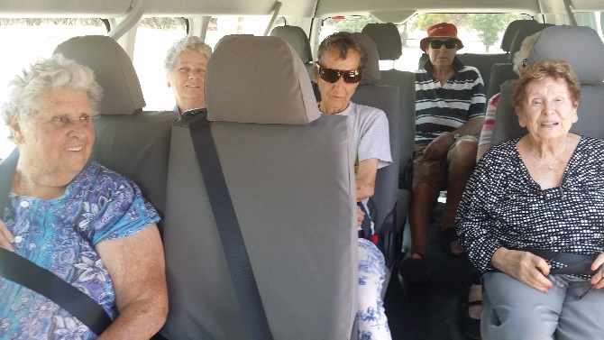
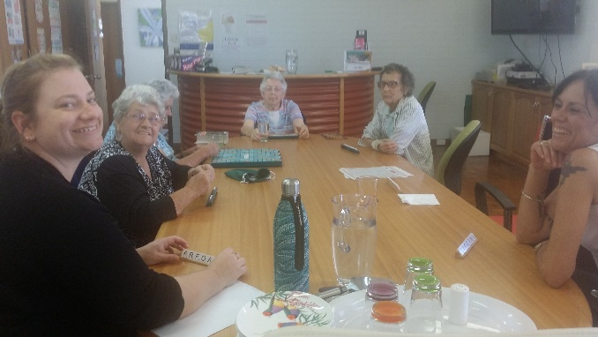

1.2 Westonia Locality
Located in Western Australia's Wheatbelt, 316 kilometres east of Perth, 306 kilometres west of Kalgoorlie and 55 kilometres east of Merredin on the Wheatbelt Way drive trail the Shire of Westonia is renowned for its stunning natural woodlands, breathtaking granite outcrops, beautiful wildflowers and vast open skies

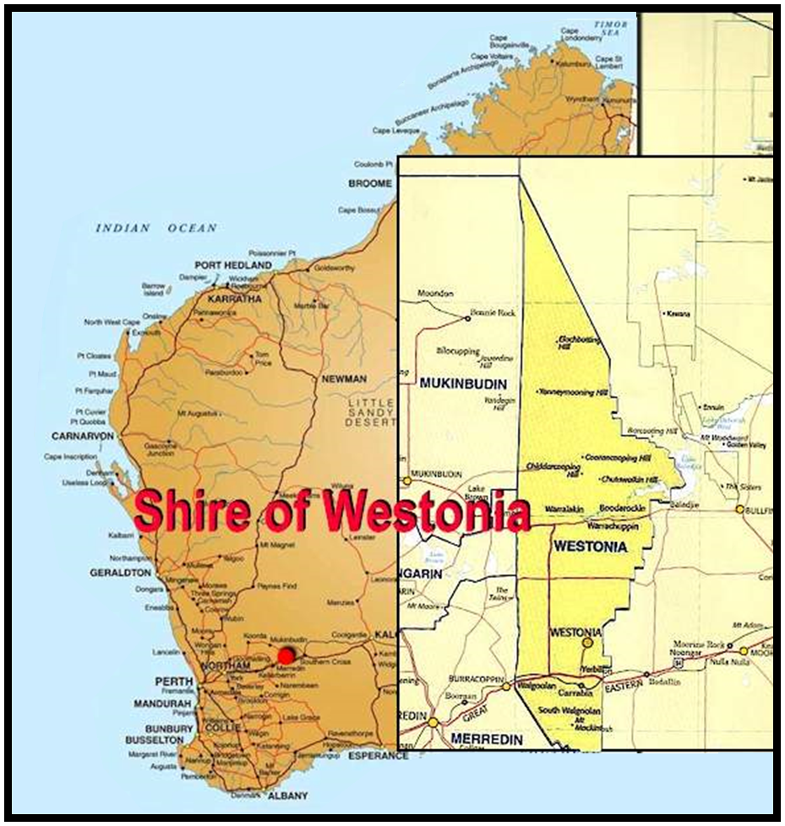

Responsibility for Planning Process
The development of the Shire of Westonia Disability Access and Inclusion Plan was undertaken by staff from across the organisation, taking into consideration changes in structure, technology and expectations.

The final version of the DAIP will be endorsed by Council and it is the responsibility of all officers to implement the relevant actions.

Functions, Facilities and Services (Both in-house and contracted)
The Shire of Westonia is governed by six elected members of Council, who are responsible for an annual budget of about $2.29 million. The Shire of Westonia provides a range of functions, facilities and services including:

    - Services to property:
Construction and maintenance of roads and footpaths; storm water drainage; domestic waste collection and disposal; waste motor oil collection facility; drumMUSTER collection services and facility; litter control and street cleaning; street tree and roadside tree pruning; bushfire control; dog control; and care and maintenance of parks and gardens.

Recreation Services to the community:
Provision and maintenance of outdoor playing areas, including the public swimming pool facility, children’s playground, and heritage walk trail; plus provision and maintenance of the sporting complex with its social lounge/bar facilities and an indoor hall which carters for basketball/netball/volleyball/hockey/and tennis.

General Services to the community:
Providing rooms for the visiting doctor service; a public library; Community Resource Centre provide and take bookings for the community bus; cooperative general store (building and management); small caravan park; and cemetery.

Local Government Regulatory Services to the community:
Planning processes; building control; environmental health; public health; and dog ranger service.

Local Government Administration Services to the community:
provision of general information to the public; lodging and resolution of complaints; collection of rates; vehicle licensing; firearms licensing; and dog registrations.

Processes of Local Government:
Ordinary and special council and committee meetings; electros meetings; and election of council members.

Access and Inclusion Policy Statement for People with Disabilities, Their Families and Carers
The Shire of Westonia is committed to ensuring that the community is an accessible and inclusive community for people with disabilities, their families and carers.

The Shire of Westonia interprets an accessible and inclusive community as one in which all council functions, facilities, and services (both in-house and contracted) are open, available and accessible to people with disabilities, providing them with the same opportunities, rights and responsibilities enjoyed by all other people in the community.

The Shire of Westonia recognizes that people with disabilities are valued members of the community who make a variety of contributions to local social, economic and cultural life. The Shire believes that a community that recognizes its diversity and supports the participation and inclusion of all its members makes for a richer community life.

The Shire of Westonia believes that people with disabilities, their families and carers who live in country areas should be supported to remain in the community of their choice.

Community Consultation Process
In 2016, the Shire undertook to review its Disability Access and Inclusion Plan (DAIP), advertised for public comment or input into this review, consulted with local Shire staff, and drafted this new DAIP to guide further improvements to access and inclusion into the future.

The process included:-
    - Examination of the latest version of the Shire’s DAIP and subsequent review reports to see what has been achieved and what still needs to be considered/done;
    - Investigation of contemporary trends and good practice in access and inclusion;
    - Consultation with key staff, and consultation with the community.

An advertisement was placed in the local community newsletter, The Westonian, asking for interested people to nominate to be on a working committee to review and develop the Shire’s new DAIP or to provide advice on aspects that should be included in the DAIP. People were advised that the process would probably take 1-2 meetings to determine the aspects to be included in the DAIP, and that the final plan would need to be adopted by Council. Unfortunately no one from the community nominated themselves. Therefore the DAIP was drafted by Shire staff and has been advertised for public comment.

People with Disability in the Shire of Westonia
From the Australian Bureau of Statistics (ABS) Survey of Disability, Ageing and Carers, Australia: Summary of Findings 2015 there has been an overall fall in the Australian disability rate in the six years from 2009 to 2015, with the rates for Victoria, Queensland, Western Australia, and South Australia decreasing the most. Between 2009 and 2015, the largest reduction in the disability rate at the state level occurred in Queensland, which dropped from 22.1% to 17.9%. Victoria, Western Australia, and South Australia had reduction rates of 20.0% to 18.4%, 20.6% to 17.4%, and 23.8% to 20.9%, respectively.

Since 2009, the proportion of Australians disabled because of physical health conditions such as asthma and back problems declined. In Western Australia disability caused by physical conditions dropped from 16.8% to 14.5%, including a significant decrease in disability caused by asthma (dropping from 0.8% to 0.4%).
Disability caused by mental and behavioral disorders also dropped, from 3.9% to 2.9%, including a significant drop in disability caused by psychoses and mood affective disorders (1.3% to 0.8%).

Four million Australians (18.5%) had a disability in 2015 and over a million Australians had a profound or severe core activity limitation (5.8%). Rates of profound or severe core activity limitation were highest in Tasmania (6.8%), South Australia (6.4%) and Victoria (6.2%), and lowest in the Northern Territory (4.0%) and the Australian Capital Territory (4.5%) reflecting the age structure of these regions.

Referring to the Disability Services Commission of Western Australia’s (DSC) website information sheet Profile of Disability for the Shire of Westonia, the figures are based on the 2003 Survey of Disability Ageing and Carers (SDAC) data from the ABS and are estimate figures only. Out of a total population in 2015 of 224 people it was estimated that 35 people had at least one disability. Out of this 35 people, there are 25 males with disabilities and approximately 19 females with core activity limitation of which some are considered a disability. Of this 35 people with disabilities, 14 are sensory disabilities, and 21 are physical disabilities. The information also indicates that within the Shire there are 12 people aged 15 years or more who require accommodation support; 7 people aged 15 years or more who require assistance with transport; and 19 people of all ages who require assistance with personal and health care.

A copy of the Australian Bureau of Statistics Survey information for 2015 and the Disability Services Commission of WA’s profile of disability information sheet are attached.

Due to the size of the population and its proximity to the Shire of Merredin, which is a regional centre, there are very limited facilities provided in the Westonia Shire for people living with disabilities.

There is no hospital, or daily medical service provided within the Shire, however, a local Nurse Practitioner visits Westonia townsite each week plus a Community Nurse from Southern Cross visits every 6 weeks to take blood samples or other duties, and both work

out of a room in the Council Administration Office and Library building. Several local residents give their time and resources to drive people to Merredin for medical appointments if they have no other means of getting there. The toilet facilities in the Council Administration Office, the Recreation Centre, and the public toilets have facilities suitable for people with mobility disabilities. There is no specific aged accommodation available within the Westonia townsite.

ACCESS AND INCLUSION POLICY STATEMENT FOR PEOPLE WITH DISABILITY, THEIR FAMILIES AND CARERS
The Shire of Westonia is committed to ensuring that the community is accessible and inclusive for people with disabilities, their families, and carers.

The Shire of Westonia also interprets an accessible and inclusive community as one in which all Council functions, facilities, and services (both in-house and contracted) are as open, available and accessible to people with disabilities as for other people in the community.
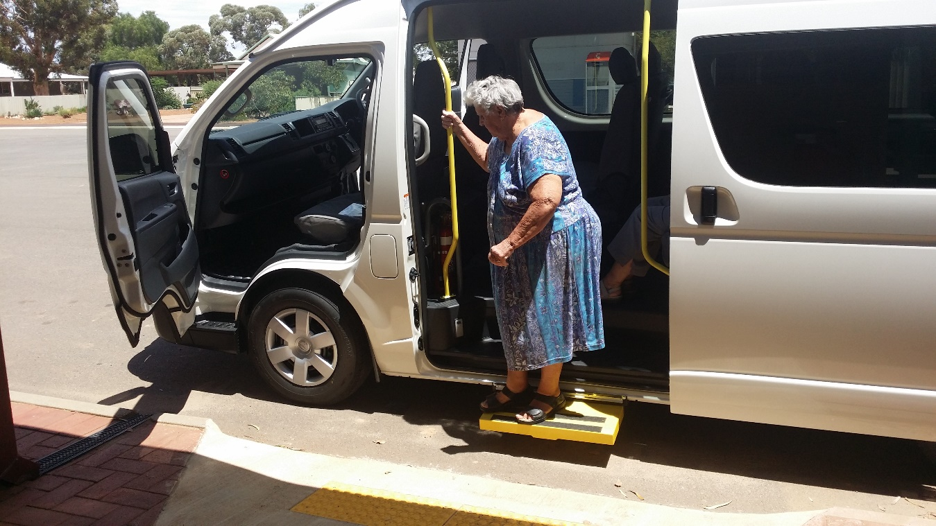
The Shire of Westonia:
- recognizes that people with disabilities are valued members of the community who make a variety of contributions to local, social, economic, and cultural life.
- believes that a community that recognizes its diversity and supports the participation and inclusion of all its members makes for a richer community life.
- believes that people with disabilities, their families and carers should be supported to remain living and participating in the community.
- is committed to consulting with people with disabilities, their families and carers, and the community in general, to ensure that barriers to access and inclusion are appropriately addressed.
- is committed to supporting local community groups and other relevant organizations to facilitate the inclusion of people with disabilities through access to information, services, and facilities in the community.
- is committed to ensuring that its agents and contractors work towards the desired outcomes in the Town’s DAIP.

The Shire of Westonia is also committed to achieving seven desired outcomes through its DAIP. They are:-

- People with disabilities, their families and carers have the same opportunities as other people to access the services of, and any events organized by, the Shire of Westonia.
- People with disabilities have the same opportunities as other people to access all buildings of a public nature, plus other facilities provided by the Shire of Westonia.
- People with disabilities receive information from the Shire of Westonia in a format that will enable them to access the information as readily as other people are able to access it.
- People with disabilities receive the same level and quality of service from the staff of, and contractors/agents to, the Shire of Westonia.
- People with disabilities have the same opportunities as other people to make complaints to the Shire of Westonia.
- People with disabilities have the same opportunities as other people to participate in any public consultation process with the Shire of Westonia.
- People with disability have the same opportunities as other people to obtain and maintain employment with a public authority.

DEVELOPMENT OF THE DISABILITY ACCESS AND INCLUSION PLAN

3.1 Responsibility for the planning process
An Access and Inclusion Planning Committee (AIPC) was established in June 2016 comprising of the Shire administration staff. No members of the community or Council indicated a desire to be part of this working Committee.
The Shire of Westonia’s Access and Inclusion Plan is for the period of 2017 – 2021.

3.2 Review and Community Consultation Process
In 2016, the Shire of Westonia undertook to review its Disability Access Plan to guide further improvements to access and inclusion. The process included:

- Examination of the current Disability Access Plan and subsequent progress reports to see what has been implemented to date, and to decide which areas require ongoing attention;
- Consultation with key staff;
- Consultation with key members of the community.

The Disability Services Act Regulations 2004 set out the minimum consultation requirements for public authorities in relation to Disability Access and Inclusion Plans. Local Governments must call for submissions, either general or specific, by notice in a newspaper circulating in the Local Government area or on any website maintained by or on behalf of the Local Government.
The following consultation methods were used:-
- In May/June 2016 a public notice was published in the local fortnightly newsletter advising the community that the Shire of Westonia intended to review its Disability Access and Inclusion Plan and asked for interested people to either nominate to be on a working committee that would have 1or 2 meetings to review the Plan, or to make suggestions/recommendations of issues that should be included in the revised Plan.
- No one (local resident or Councillor) indicated a desire to be part of the working committee, so the review of the Plan has been carried out by the Shire administration staff.

3.3 Findings of the Review
The review found that a number of objectives listed in the reviewed Disability Access and Inclusion Plan had been achieved and that a new plan was required to address the remaining access barriers and issues regarding inclusion as required by the current legislation.

Access Barriers
The review identified a variety of remaining barriers to access and inclusion that are addressed in this DAIP.

There has been a range of barriers identified in the DAIP that still require redress, as outlined in Appendix I. Those that have been addressed are listed below in colour, and any remaining access and inclusion barriers are listed in black:
  - the front counter at the Shire administration building requires a section to be lowered to improve access to staff rather than speaking to them from the side of the service counter;
  - removing un-even footpaths along the main street;
  - ensuring that the sloped access from footpath to road surface has a minimal or no trip lip;
  - identify car parking spaces for people with disabilities to use outside public facilities;
  - the shoe mat in front of the front door to the Westonia Co-Operative store should be set into the brick paving to be level with the pavers and not be an impediment to shoppers;
  - unisex toilets for people with disabilities have not been provided yet at the public swimming pool facility;
  - a unisex ablution facility suitable for people with disabilities has not been provided at the Westonia Caravan Park;
  - provide signage to facilities for people with disabilities in Braille as well as normal visual symbols;
  - access from pathways to laundry and ablution facilities at the Westonia Caravan Park needs to be sloped at 1:14 gradient rather than via the current steps;
  - no purpose built aged accommodation units have been constructed as yet to help assist older members of the community to continue to live in Westonia; and
  - the Council website requires improvements to best meet the needs of people with disabilities and/or language issues by providing links with other service providers.

The identification of these and the additional newly identified barriers formed the development of strategies in this DAIP. The barriers have been prioritised in order of importance, which assists in setting timeframes for the completion of strategies to overcome those access and inclusion barriers.

3.4 Responsibility for implementing the DAIP
It is a requirement of the Disability Services Act that public authorities must take all practical measures to ensure that the DAIP is implemented by its officers, employees, agents, and contractors. Implementation of the DAIP is the responsibility of all areas of the Shire of Westonia. All of the actions in the Implementation Plan will apply to the Westonia townsite. The Implementation Plan sets out who is responsible for each action.

3.5 Communicating the plan to staff and people with disabilities
- On completion, a copy of the Disability Access and Inclusion Plan was distributed to other members of the Shire administration staff for comment.
- Council advertised the DAIP in its local newsletter advising that copies can be obtained from the Shire administration office.
- Copies of the DAIP will be made available via the Shire’s website, as well as in alternative formats.
- As DAIPs are amended, both Shire staff and the community will be advised of the availability of updated plans.

3.6 Review and evaluation mechanisms
The Disability Services Act outlines the minimum review requirements for public authorities in relation to DAIPs. The Shire of Westonia’s current DAIP will be reviewed at least every 5 years, in accordance with the Act.

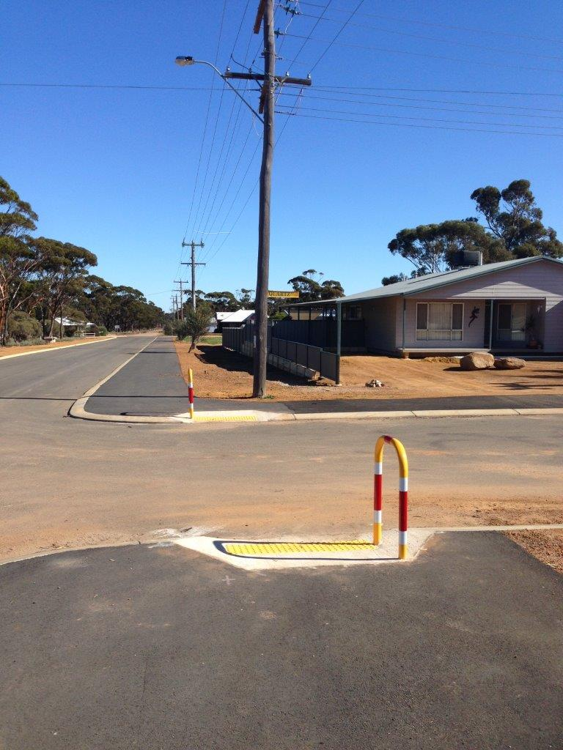
The DAIP Implementation Plan may be amended on a more regular basis to reflect progress and to action any access and inclusion issues as they arise. Whenever the Shire’s DAIP is amended, a copy of the amended plan will be lodged with the Disability Services Commission.

3.7 Review and monitoring
- The Access and Inclusion Planning Committee will conduct an ongoing review of progress in implementing the DAIP and provide a report to Council on progress and recommendations for changes to the implementation plan on a regular basis.
- The DAIP will be reviewed and submitted to the Disability Services Commission each financial year. The report will outline what has been achieved under the Shire of Westonia’s DAIP in that financial year.

REPORTING ON THE DAIP
The Disability Services Act sets out the minimum reporting requirements for public authorities in relation to DAIPs.

The Shire of Westonia will report on the implementation of its DAIP through its annual report and the prescribed proforma to the Disability Services Commission by 30 June each year, outlining:
- Progress towards the desired outcomes of its DAIP;
- The strategies used to inform its agents and contractors of its DAIP; and
- Provide a brief description of any significant DAIP initiatives undertaken by or on behalf of the organization by contractors.

STRATEGIES TO IMPROVE ACCESS AND INCLUSION

The following overarching strategies have been developed to address each of the seven desired outcome area of the Plan. These will form the basis of the Implementation Plan.

Outcome 1: People with disability have the same opportunities as other people to access the services of, and participate in any events organised by, a public authority.

    - Council will endeavor to be adaptable in responding to the barriers experienced by people with various disability, including people with physical, sensory, cognitive and psychiatric disabilities.
- Ensure policies and procedures relating to access and inclusion are integrated within the practices of the organisation
- Ensure staff, agents and contractors are aware of the relevant requirements for providing access and inclusion to services and events and have access to relevant resources to support this.
- Indicate on promotional materials if an event is accessible for wheelchairs and mobility devices, and if special assistance is available to attendees upon request.
- Increase awareness of specialized services, such as the Social Inclusion Program, which offer additional services to disadvantaged people, including people with disability.
- Incorporate the objectives of the DAIP into strategic planning and other relevant plans and strategies where relevant.

Outcome 2: People with disability have the same opportunities as other people to access buildings and other facilities of a public authority.

      - Council will undertake to incorporate the priorities regarding access for people with disability, identified during the consultations, into its submission for its capital works improvement program. Modifications will commence as funds are made available.
      - Council will undertake to liaise with developers to increase their awareness of the access requirements of people with disability.
- Continue to implement processes to ensure safety and accessibility are maintained whilst works are in progress
- Ensure that all facilities and infrastructure complies with minimum access standards as required by Australian Standards on Access and Mobility (ie: AS 1428 suite) and are physically accessible and safe: particularly pedestrian facilities such as footpaths, bus stops, parks, reserves, gardens etc.
- Ensure that all future regional and district playground renewal projects have at least one piece of equipment in each playground that is accessible and inclusive for all people, including children with a disability.
- Investigate opportunities for employees to attend training on the correct installation of warning and directional Tactile Ground Surface Indicators.
- Consider opportunities to educate community on shared path rules.

Outcome 3: People with disability have the same opportunity as other people to access information in a format that will enable them to access the information as readily as other people are able to access it.

      - Council will produce all of its information on Council facilities, functions and services using clear and concise language. The advice provided electronically can be enlarged by font amendments and on request at the administration
- Improve staff awareness of accessible information needs and how to provide information in other formats
- Ensure that upgrades to the website are in a format suitable for people with disability and readable with screen-readers and other assistive technology
- Improve staff ability to write in Plain English so that materials are more accessible to people with cognitive difficulties

Outcome 4: People with disability receive the same level of service from the employees of a public authority as other people receive from the employees of that public authority.

      - Council will undertake to ensure that staff is aware of the key access needs of residents with disability and people with disability who visit the local government area in relation to the provisions of all services.
- Improve staff knowledge of skills available to them within the current staff.
- Review, and if necessary, develop policies and procedures for improving service accessibility to people with disability to ensure that they receive the same level of service as others.
- Ensure professional development and support is available for staff providing services to people with disability
- Include Disability Awareness training as part of induction.

Outcome 5: People with disability have the same opportunities as other people to make complaints to a public authority.

- Ensure people with disability are provided an opportunity to comment on facilities, services and events.
- Ensure existing staff who have direct contact with the public (reception/front counter) complete training.
- Develop and implement an Access and Inclusion feedback form
- Ensure computerised grievance procedures which cater for the needs of the whole community, including people with disability, continue to be implemented. Options for making complains include; in person, by letter, fax, email, via the website, customer service request

Outcome 6: People with disability have the same opportunities as other people to participate in any public consultation by a public authority.

      - Council will ensure that information is available in a clear and concise language on how residents can participate in decision-making processes, public consultation and grievance mechanisms.
- Provide sufficient notice of meetings, suitable venues and an appropriate level of support to people with disability who are directly involved in consultation processes.
- Widely promote opportunities for consultation through:
- Newspapers including focus page, advertising and media releases
- Website
- Letter writing to key agencies/sites and residents & ratepayers associations (refer to Seniors Directory)
- A survey
- Newsletters
- A letterbox drop
- Questionnaires
- Focus groups/review groups
- Mailing list for people with disability available from Community Development
- Provide six to eight weeks feedback time for public consultation questionnaires.
- Ensure consultation documents are available for comment and any outcome or findings are located on the website and in alternative formats on request.
- Provide feedback from public consultation to key agencies/sites and promotion through the media where appropriate.

Outcome 7: People with disability have the same opportunities as other people to obtain and maintain employment with a public authority.

      - Work with local employment support providers to employ a person with a disability when positions are available.
      - Undertake an audit of equipment and resources to identify any requirements to support staff with a temporary or permanent impairment.
- Review employment practices annually (Equal Employment Opportunity plan) to ensure recruitment process and practices meet the requirement for the employment of people with disability.
- Conduct regular education/information sessions for managers to improve awareness.
- Provide entry level employment and pathways through on-the-job training opportunities (e.g. work experience placements for people with disabilities, casual work).
- Ensure Job Descriptions include a clear and precise description of the tasks required to be undertaken for the advertised position.

6. IMPLEMENTATION PLAN
The Implementation Plan details the task, timelines and responsibilities for each strategy to be implemented to progress the strategies of the DAIP.

It is intended that the Implementation Plan will be updated annually, as and when required, to progress the achievements of all the strategies over the duration of the five year plan.

Outcome 1: People with disability have the same opportunities as other people to access the services of, and participate in any events organised by, the Shire of Westonia:

Strategy | Task | Timeline | Responsibility
Ensure that people with disability are consulted on their need for services and the accessibility of current services. | - Develop a feedback mechanism for use of all persons with a disability who use services by the Shire.  - Provision of domestic refuse collection service from inside residential property boundaries available to persons with an access and mobility challenge | Ongoing | Chief Executive Officer & Administration Officer
Monitor Shire services to ensure equitable access and inclusion. | - Conduct systematic review of accessibility of services  - Rectify identified barriers | Ongoing | Environmental Health & Building Officer, Administration Staff & CEO
Ensure that events, whether provided or funded, are accessible to people with disability. | - Ensure all events are planned using the Accessible Events Checklist. | Ongoing | Chief Executive Officer & Administration Officer

Outcome 2: People with disability have the same opportunities as other people to access buildings and other facilities of the Shire of Westonia.

Strategy | Task | Timeline | Responsibility
Ensure that all buildings and facilities meet the Australian Standards for access and any demonstrated additional needs. | - Continue to address access barriers to Shire buildings and facilities.  - Prioritise and make submission to Council to commence works on identified barriers.  - Where required investigate public concerns regarding access to all buildings – private sector included for compliance and required upgrades. | Ongoing | Environmental Health & Building Officer
Ensure that all redevelopment works provide access to people with disability, where practicable. | - Ensure that upgrades of publicly accessed buildings provides for persons with disability.  - Ensure no building application is signed off without meeting the legal requirements for access & inclusion. | Ongoing | Environmental Health & Building Officer
Remove un-even footpath surfaces along the main street | - Identify sections of footpaths that are uneven and include these in the Council Footpath Program either as a capital item if extensive work is required, or as maintenance if a small area of work is required.  - Allocate funds for the repair or maintenance of footpaths in Council’s Annual Budget figures. | Ongoing  Footpaths have been upgraded 2015/16 | Works Manager
Ensure that the sloped access from footpath to road surface has a minimal or no trip lip | - Identify sloped ramps between footpaths and road surfaces that have a “lip” of more than 5mm and include these in the annual Shire Works Program. | Ongoing | Works Manager
Encourage TransWA to provide access to passenger trains by people with disabilities at the Carrabin Train Station. | - Continue discussions with TransWA regarding the installation of a raised platform to assist people with disabilities to access passenger trains at the Carrabin Train Station. | Ongoing | Environmental Health & Building Officer, and CEO

Outcome 3: People with disability receive information from the Shire of Westonia in a format that will enable them to access the information as readily as other people are able to access it.

Strategy | Task | Timeline | Responsibility
Ensure that the community is aware that information is available in alternative formats on request. | - Advertise the availability of alternative formats in the local paper and radio.  - Ensure all documents that require community consultation carry a notation that the document is available in alternative formats.  - Maintain and regularly update the Webpage for continuity of documents and information | Ongoing | Chief Executive Officer & Administration Officer
Improve employee awareness of information available in alternative formats. | - Advise staff of the various alternative information formats that can be produced in-house, and those that need to be done by others.  - Train employees in providing accessible information and notation requirements. | Ongoing | Environmental Health & Building Officer, Administration Staff & CEO
Ensure that Councils website meets contemporary good practice | - Web access to public records available at www.westonia.wa.gov.au, Monthly newsletter – local newspaper, notice board. | Ongoing | Environmental Health & Building Officer, Administration Staff & CEO
Provide documentation regarding services, facilities & customer feedback in an appropriate format using clear concise language. | - Adopt State Government Guidelines for Information, Services and Facilities, and incorporate into general practice by Council staff. | Ongoing | Environmental Health & Building Officer, Administration Staff & CEO

Outcome 4: People with disability receive the same level of service from the employees of a public authority as other people receive from the employees of the Shire of Westonia

Strategy | Task | Timeline | Responsibility
Ensure that Council Members and employees are aware of access needs and can provide appropriate services. | - Key Council officers to have disability awareness training. The Disability Services Commission and relevant disability organisations to be contacted for assistance in the development of training. | Ongoing | Chief Executive Officer & Administration Officer
People with disabilities to be informed that alternative arrangements for the removal of rubbish can be made upon request. | - Advertise regularly in the Council newsletter that this service is available | Ongoing | CEO
People with mobility problems to be informed that prior arrangement can be made with Council for transport from Westonia to near by essential services | - Advise regularly in the Council newsletter that this service is available | Ongoing | CEO

Outcome 5: People with disability have the same opportunities as other people to make complaints to the Shire of Westonia.

Strategy | Task | Timeline | Responsibility
Ensure that grievance mechanisms are accessible for people with disability and are acted upon. | - Review current grievance mechanisms, and consult with locals to determine their accessibility.  - Develop other methods of making complaints such via a website or E- mail.  - Advertise in the Council newsletter the various methods of making a complaint to Council. | Ongoing | Environmental Health & Building Officer, Administration Staff & CEO
Improve staff knowledge so they can facilitate the receipt of complaints from people with a disability | - Incorporate good practice in handling complaints from people with disabilities into induction and disability awareness training. | Ongoing | Environmental Health & Building Officer, Administration Staff & CEO

Outcome 6: People with disability have the same opportunities as other people to participate in any public consultation by Shire of Westonia.

Strategy | Task | Timeline | Responsibility
Ensure that people with disability are actively consulted about the AIP and any other relevant planning processes. | - Consult with people with disability using a range of different mediums, for example, survey, interview, focus group. | Ongoing | Environmental Health & Building Officer, Administration Staff & CEO
Ensure that people with disability are aware of, and can access, other established consultative processes. | - Ensure all documents that require community consultation are available in alternative formats. | Ongoing | Chief Executive Officer & Administration Officer

Outcome 7: People with disability have the same opportunities as other people to obtain and maintain employment with the Shire of Westonia.

Strategy | Task | Timeline | Responsibility
Use inclusive recruitment practices | - Include Equal Employment Opportunity statement in the advert. For example “promotes a workplace that actively seeks to include, welcome and value unique contributions of all people. Encourages people with disability, Aboriginal Australians, young people and people from culturally diverse backgrounds to apply.  - Ensure that positions for which persons with disability are advertised to the relevant public recruitment groups | Ongoing | Environmental Health & Building Officer, Administration Staff & CEO
Awareness Training | - Make provision for regular disability awareness training for all staff | Ongoing | Chief Executive Officer & Administration Officer
Supporting Equipment & Resources | - Undertake an audit of equipment and resources to identify any requirements to support staff with a temporary or permanent impairment;  - Plan for any identified supporting equipment or resource | Ongoing | Environmental Health & Building Officer, Administration Staff & CEO

NOTES
Not all positions offered will suit a person with disability – e.g. a truck driver/grader operator requires a large degree of dexterity that is required to complete tasks.

PROGRESS SINCE 1995 UNDER THE DISABILITY SERVICE PLAN AND THE DISABILITY ACCESS AND INCLUSION PLAN.
Outcome 1: People with disability have the same opportunities as other people to access the services of, and participate in any events organised by, a public authority

- Where applicable, grant fund applications do and will include access to new or existing facilities as part of the criteria for the application.
- People with disabilities are able to comment on the Shire’s activities by various means such as letters, E-mails, telephone, coming into the Shire office, or having comments delivered via family/friends.
- A copy of the current Shire’s DAIP has been added to it’s website. There is a link on the website to the Disability Services Commission of WA’s website too.
- The Shire Library has increased the number of audio books (talking books) and large print books held at the library, and these are regularly rotated through the WA LISA rotation program. These books are located at easily accessible levels and are signed well.
- Means of integrating people with disabilities into recreational activities has been a challenge and difficult to achieve for severely disabled people, however, those with minor disabilities are able to participate in activities readily.
- In 2010/2011 the Shire built 5 townhouses for retirees or seniors. Two of the townhouses are double story, while the other three townhouses are single story. While the single-story townhouses were not specifically designed to comply with the Australian Standards for Access and Mobility AS1428-1, they would be suitable for people with disabilities. Council has also submitted a joint business plan with the Shire of Yilgarn and was successful in building more units for aged accommodation during the 2012/13 year, once again in 15/16 financial Year council was successful in building 2 more units for aged accommodation (now totaling 4).

Outcome 2: People with disability have the same opportunities as other people to access buildings and other facilities of a public authority.

- A public toilet block has been constructed at the local playground off Cement Street near the town centre that it suitable for people with disabilities.
- Footpaths along the main street have been upgraded wherever possible.
- Access ramps from footpaths to road surface have been provided and are monitored to ensure that road subsidence does not cause a “lip” to form, and if found, these are repaired so they are functional.
- Due to the population and the number of people with disabilities within town or the Shire, the need for specific car parking bays for people with disabilities is not an issue. There are adequate car parking spaces on-road directly outside of commercial and public facilities, and Council has received no complaints with regards to this issue. Therefore this strategy is to be deleted.
- The shoe mat in front of the front door at the Westonia Co-Operative store has been inlaid in a well within the brick paved footpath so there is no longer a trip hazard.
- A purpose built unisex transportable ablution block has been installed at the accommodation camp or village for the mining company which adjoins the Westonia Caravan Park. People staying at the Caravan Park may access this ablution block.
- There are a couple of natural tourist sites within the Shire that are accessible by people with disabilities.

Outcome 3: People with disability receive information from a public authority in a format that will enable them to access the information as readily as other people are able to access it.

- Council has a policy that all information made available to the community is to be written in a clear and concise language.
- The Shire advertised through the local Council newsletter that Council information is available in alternative formats upon request.
- Council’s website is updated regularly and meets contemporary good practice standards.

Outcome 4: People with disability receive the same level of service from the employees of a public authority as other people receive from the employees of that public authority.

- Key Council officers have had disability awareness training, but this needs to be ongoing so that new staff are similarly trained.
- People with mobility problems who are unable to bring rubbish bins to the kerb side can request assistance from Shire staff to take out and bring in their rubbish bins.
- People with mobility problems who do not have transport to access essential services in nearby Merredin that are not provided in Westonia can seek assistance with transport by contacting the Shire Administration office.
- Local residents volunteer, including the Shire staff, to assist people with transport to near by essential services.

Outcome 5: People with disability have the same opportunities as other people to make complaints to a public authority.

- The Shire advertises through the local Council newsletter of any planned new works to seek public comment; any electoral matters; that Council meets on the third Thursday of each month and that the public can attend; and that complaints can be lodged at the Shire administration office in person, in writing, via telephone, or as an E-mail.
- On election day the Shire provides a mobile voting service that travels to those who are unable to go to a voting centre in the District.

Outcome 6: People with disability have the same opportunities as other people to participate in any public consultation by a public authority

- Different and broader means of communication with members of the community are achieved not only through the normal methods of publishing notices/information items in the local Westonian publication or the Council newsletter but this is a small community where most people know each other.

